**GULSHAN NAZEER TECHNICAL AND CLEANING SERVICES**

Date: <To2>

**TO WHOM IT MAY CONCERN**

This is to certify that <Name> s/o <fname> was employed with Gulshan Nazeer Technical and Cleaning Services from <From2> to <To2>. During their tenure with us, as a <Designation>

Throughout their time with Gulshan Nazeer Technical & Cleaning Service, he demonstrated remarkable dedication and professionalism. They consistently met or exceeded expectations and contributed significantly to our team. He was known for their excellent problem-solving skills, ability to work collaboratively, and strong work ethic.

We wish him all the best in their future endeavors and are confident that they will succeed in any role they pursue.

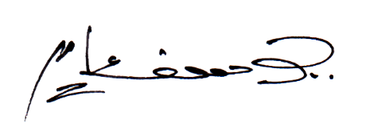

HR Manager

**GULSHAN NAZEER TECHNICAL SERVICES**

**HR**

**MANAGER**